Project Report: ServiceNow Implementation for Educational Organization

# 1. Project Title

Service Now Implementation for Educational Organization ITSM Framework

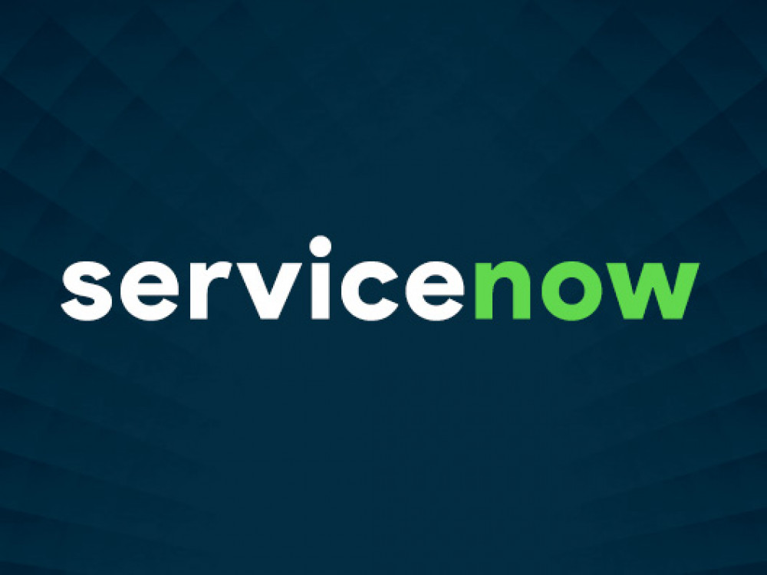

# 2. Project Overview

The project focuses on designing and implementing an IT Service Management (ITSM) solution using ServiceNow for an educational organization. The objective is to streamline incident management, change requests, service requests, and automate workflows to enhance productivity and reduce response/resolution time across academic departments.

**Project Photos:**

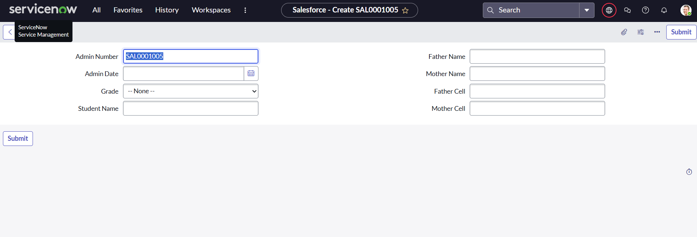

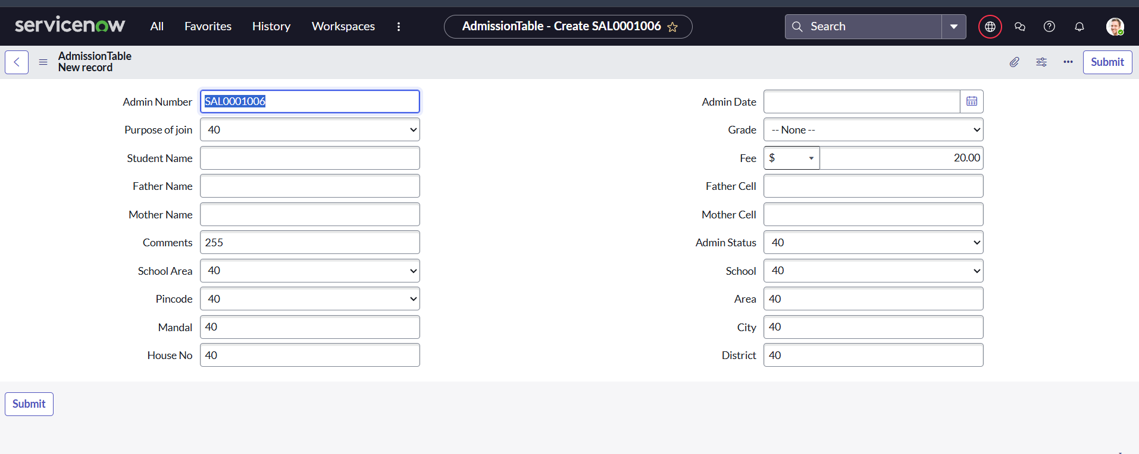

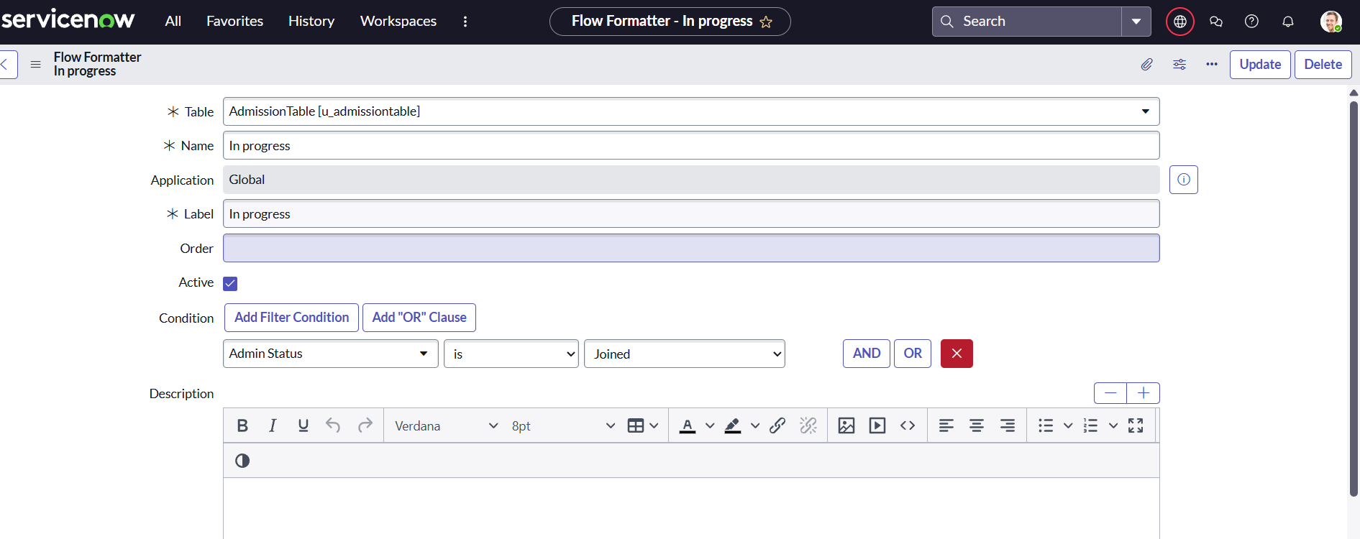

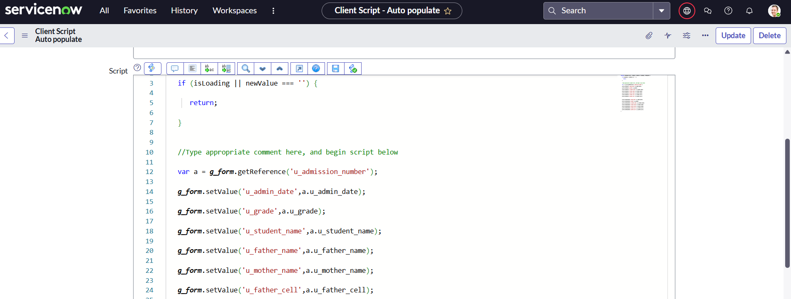

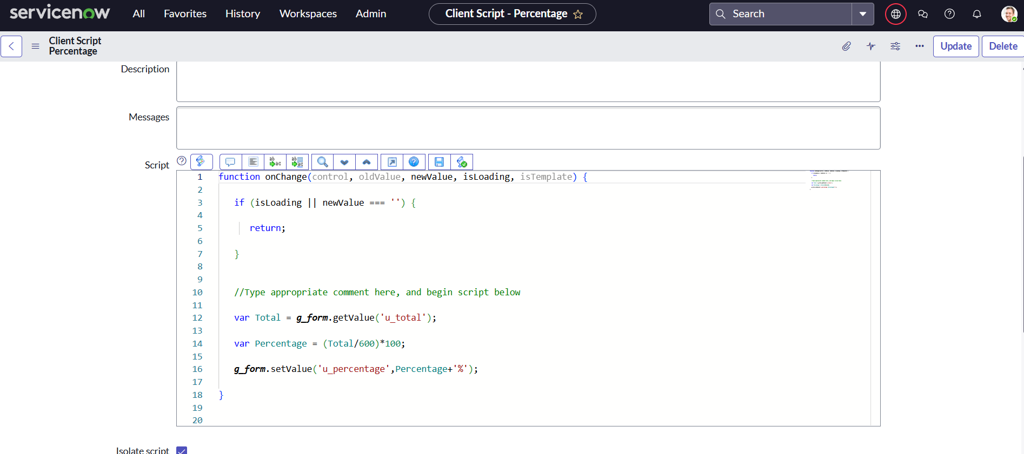

# 3. Organization Background

The organization is a mid-sized educational institution offering undergraduate and postgraduate programs. It has over 5,000 students, 400 staff members, and 100+ administrative and academic departments. Prior to ServiceNow, the organization relied on manual emails, spreadsheets, and phone calls for IT support and service management.

# 4. Objectives of the Project

- Automate IT service delivery using ServiceNow.

- Centralize incident, problem, change, and request management.

- Enhance transparency and accountability in IT operations.

- Improve service response and resolution time.

- Ensure proper tracking, documentation, and reporting.

# 5. Scope of Work

- Implement Incident Management, Change Management, Problem Management, and Service Request modules.

- Configure a self-service Service Portal for students and staff.

- Set up a knowledge base for common issues and FAQs.

- Automate email notifications and escalation processes.

- Customize workflows for academic/administrative support.

- Generate custom dashboards and SLA reports.

# 6. Tools and Technologies

- Platform: ServiceNow (Quebec / Rome / San Diego release)

- Languages: JavaScript (for client/server scripting), HTML/CSS (for UI customization)

- Modules Used: Incident, Problem, Change, Request Management, Knowledge, Service Catalog

- Integration: Email (Outlook), LDAP (for user authentication)

# 7. Key Features Implemented

- Service Catalog with predefined service items for hardware/software issues, ID card requests, lab maintenance, etc.

- Incident auto-assignment based on categories and department.

- SLA tracking with breach notifications.

- Change Management Approval Workflow for major infrastructure updates.

- Custom Knowledge Base for common issues like password reset, Wi-Fi troubleshooting.

- Reporting Dashboard showing ticket status, technician performance, SLA metrics.

# 8. Implementation Phases

|  |  |
| --- | --- |
| Phase | Description |
| 1. Requirement Gathering | Stakeholder meetings, formulating functional & technical specs |
| 2. Platform Setup | ServiceNow instance configuration and domain setup |
| 3. Module Development | Incident, Change, Problem, Request modules setup |
| 4. Testing & QA | Unit testing, UAT with sample users |
| 5. Training & Deployment | Admin and end-user training, go-live |

# 9. Challenges Faced

- Resistance to change from legacy systems.

- User training and adoption.

- Integration with existing LDAP directory and email system.

- Ensuring mobile-friendliness for student access.

# 10. Benefits Realized

- 50% reduction in average incident resolution time.

- Increased visibility into IT performance with dashboards.

- Enhanced satisfaction among staff and students.

- Real-time alerts and reporting enabled proactive support.

# 11. Future Enhancements

- Mobile app integration for ticket management.

- Automation using Virtual Agent and AI Search.

- Extend ServiceNow usage to facilities, HR, and finance departments.

- CMDB and Asset Management integration.

# 12. Conclusion

The ServiceNow implementation has transformed the IT service delivery model in the educational organization, resulting in streamlined operations, improved accountability, and measurable service improvements. The system will continue to evolve with user feedback and future integration plans.